Apache CXF Step by Step

Creating Service using CXF

- Create a normal java project in eclipse .And the package structure should look like below and add the jar files needed.
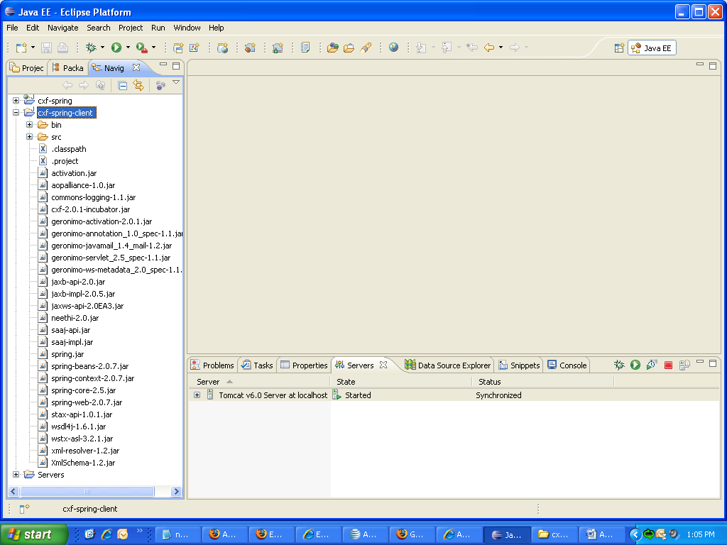

2.Add the following classes inside the src folder.

a)HelloWorld.java

package demo.spring;

import javax.jws.WebService;

@WebService
public interface HelloWorld {
String sayHi(String text);
}

b)Client.java

package demo.spring;

import org.springframework.context.ApplicationContext;
import org.springframework.context.support.ClassPathXmlApplicationContext;

public class client {

public static void main(String[] args) {

client c = new client();
c.exec();

}

public void exec() {

ApplicationContext context = new ClassPathXmlApplicationContext(
"applicationContext.xml");
HelloWorld hello = (HelloWorld) context.getBean("helloClient");
System.out.println("************inside exec**********");
hello.sayHi("antony");

}

}

c)applicationContext.xml

<?xml version="1.0" encoding="UTF-8"?>
<beans xmlns="http://www.springframework.org/schema/beans"
xmlns:xsi="http://www.w3.org/2001/XMLSchema-instance"
xmlns:jaxws="http://cxf.apache.org/jaxws"
xsi:schemaLocation="
http://www.springframework.org/schema/beans http://www.springframework.org/schema/beans/spring-beans.xsd
http://cxf.apache.org/jaxws http://cxf.apache.org/schemas/jaxws.xsd">
<jaxws:client id="helloClient" serviceClass="demo.spring.HelloWorld"
address="http://localhost:8080/cxf-spring/HelloWorld" />

</beans>

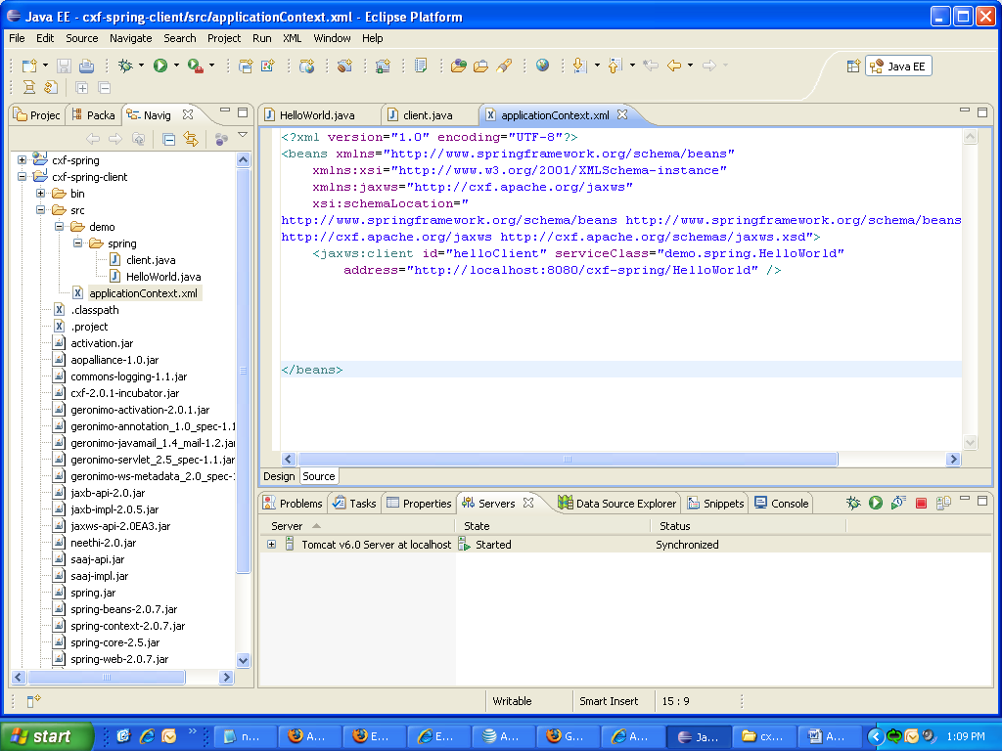

3. Now the client is ready to consume the service. So now right click on client.java and run as java application.

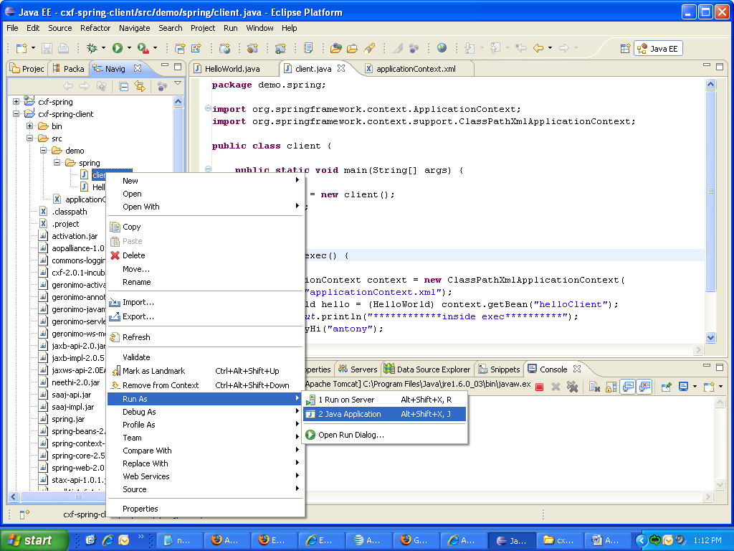

4. Then you can see the output from the service in console.

